Project of PHP-MySQL
Project Name: Food-Reservation
URL of repository: https://github.com/mijuanmontalvo/Proyecto_Food_Reservation.git
Description: Currently the application allows:
- Create user accounts and save the information in the MySQL database
- Enter the application through a login screen, for which the user must enter their username and password, these data will be verified in the database and if they are correct they will enter the application, otherwise there will be a message. incorrect username and/or password
- In the application it is possible to access the dishes section, the user will be able to create new dishes and save this information in the database
- In the application it is possible to access the reservations section, the user will be able to create new reservations and save this information in the database
- Users will be able to see only their information (reservations), they will not be able to see the information of other users.
- The application shows the dishes and reservations previously created by users.
- The application uses a database (MySQL) named food_reservation, which has three tables: dish, reservation and user.

Project Screens
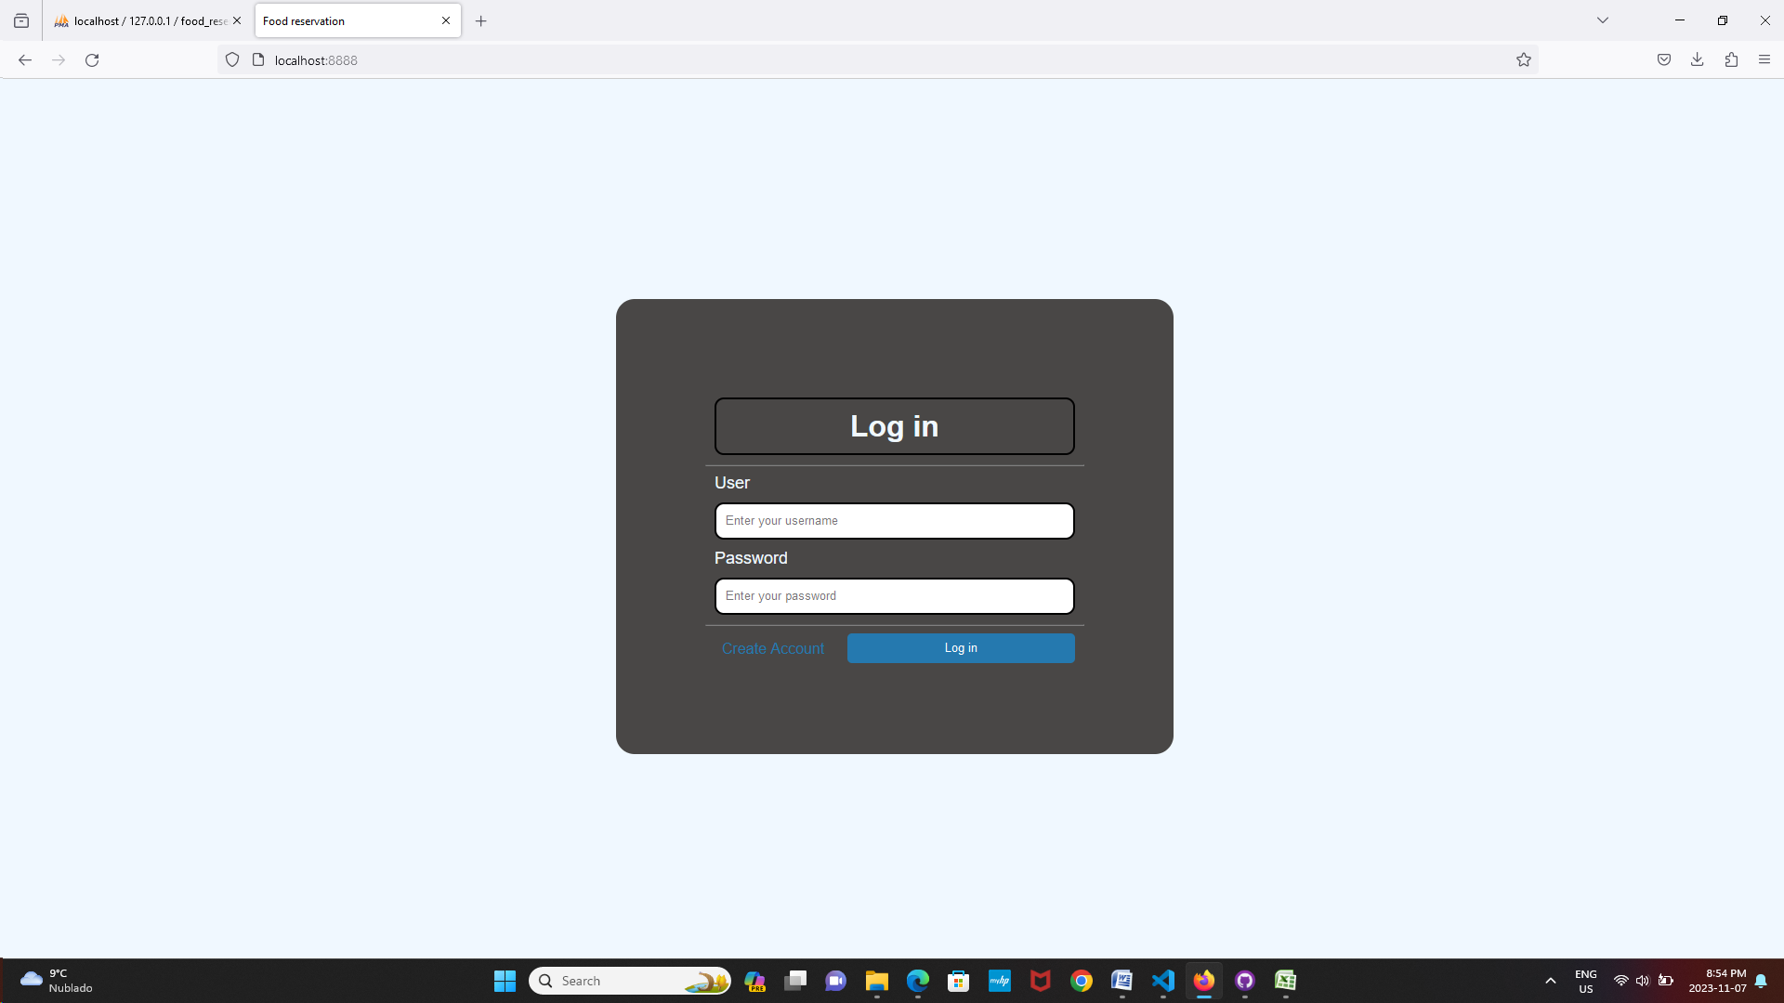
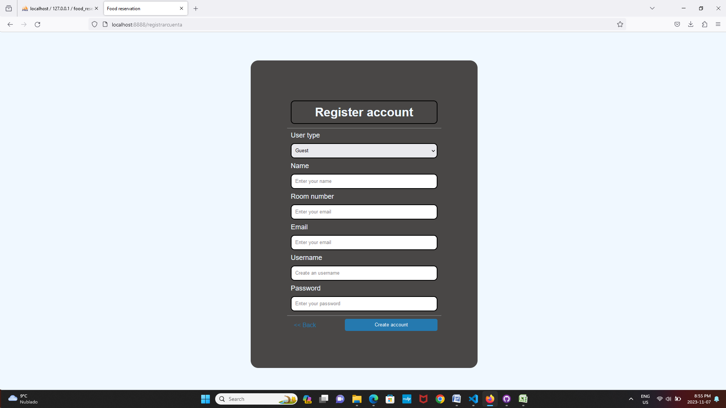
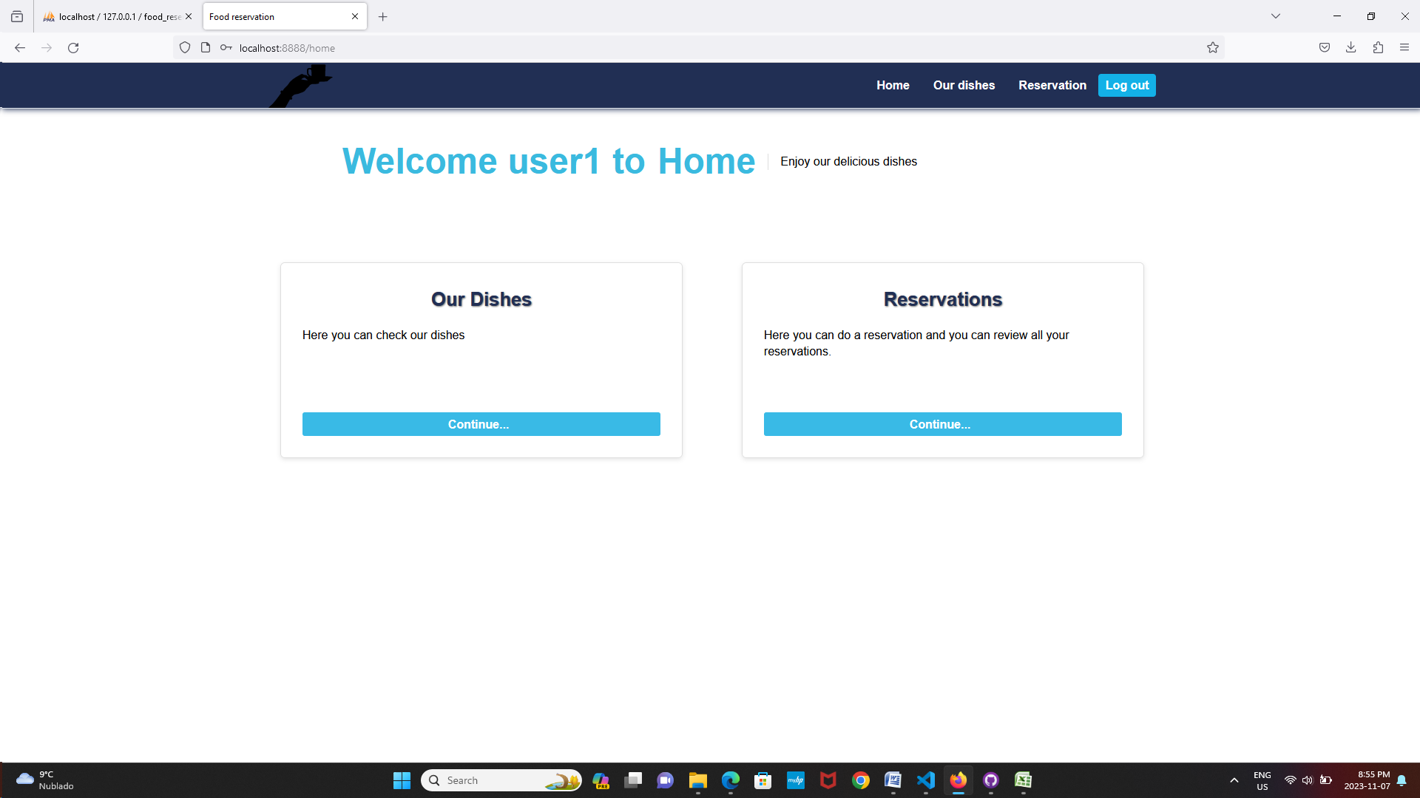
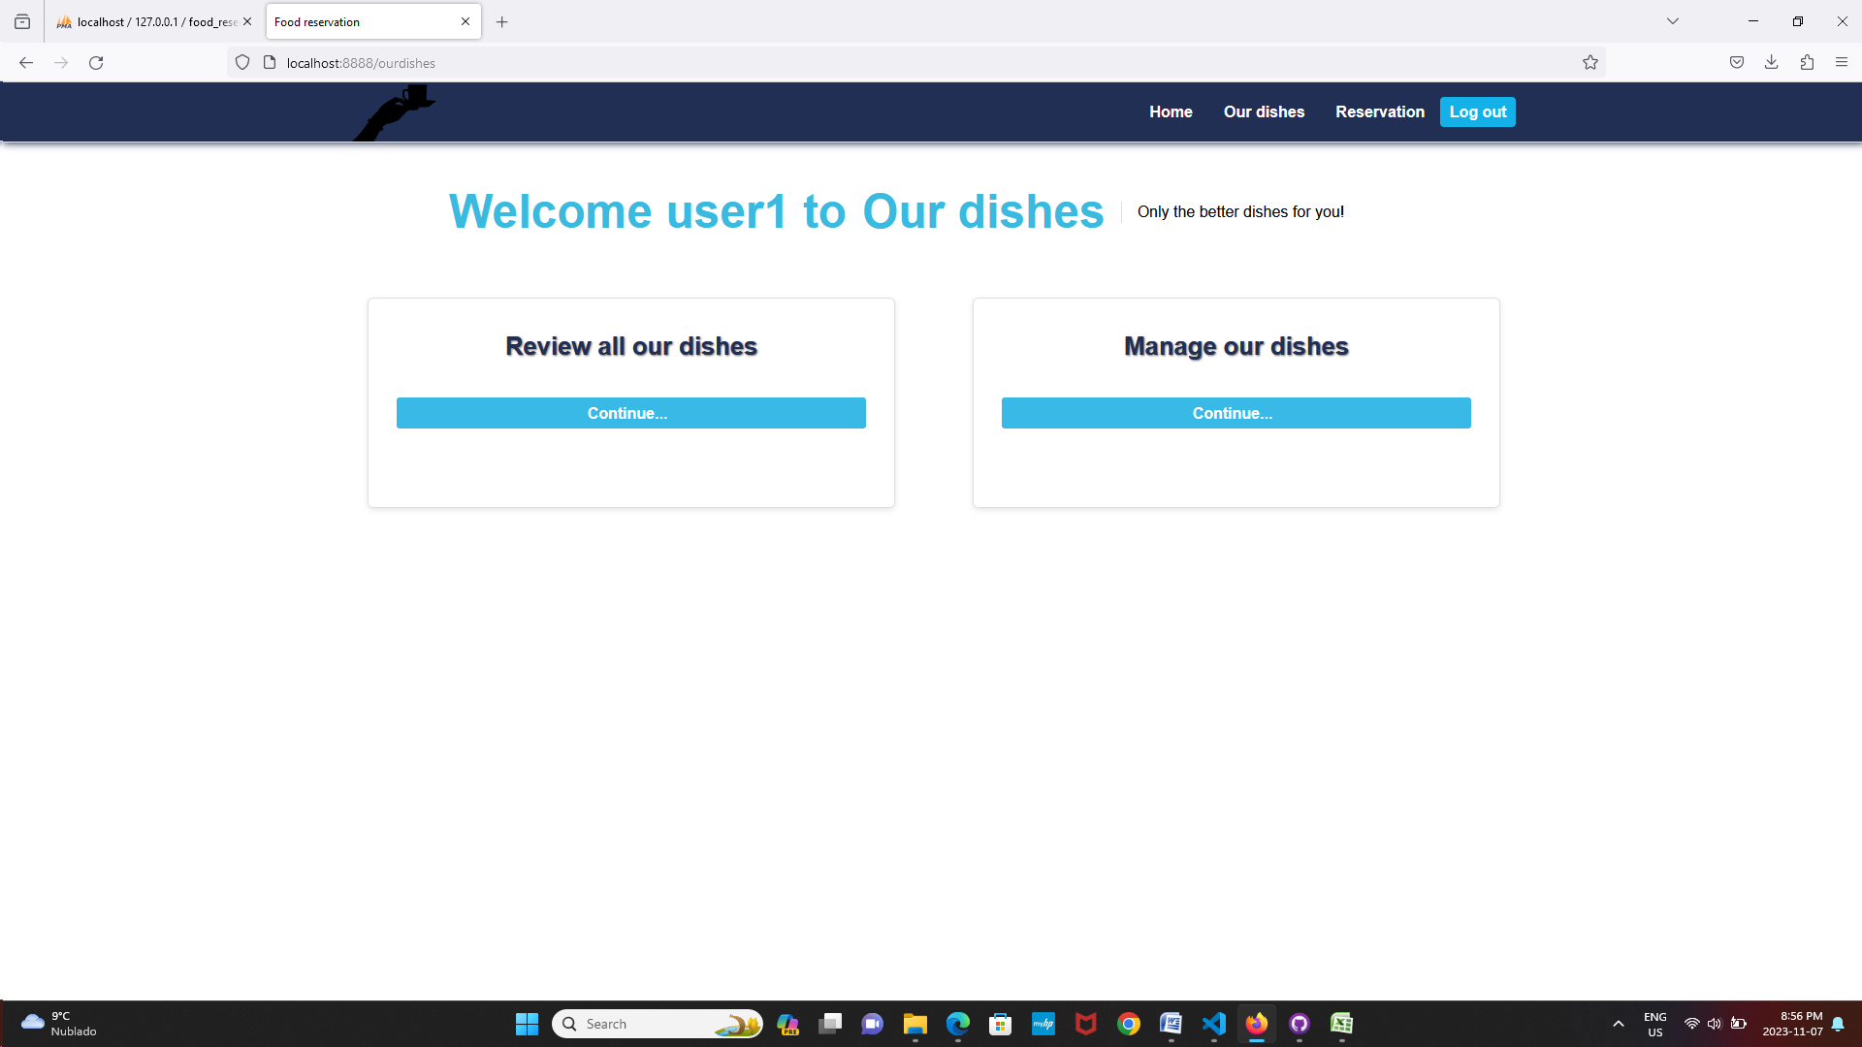
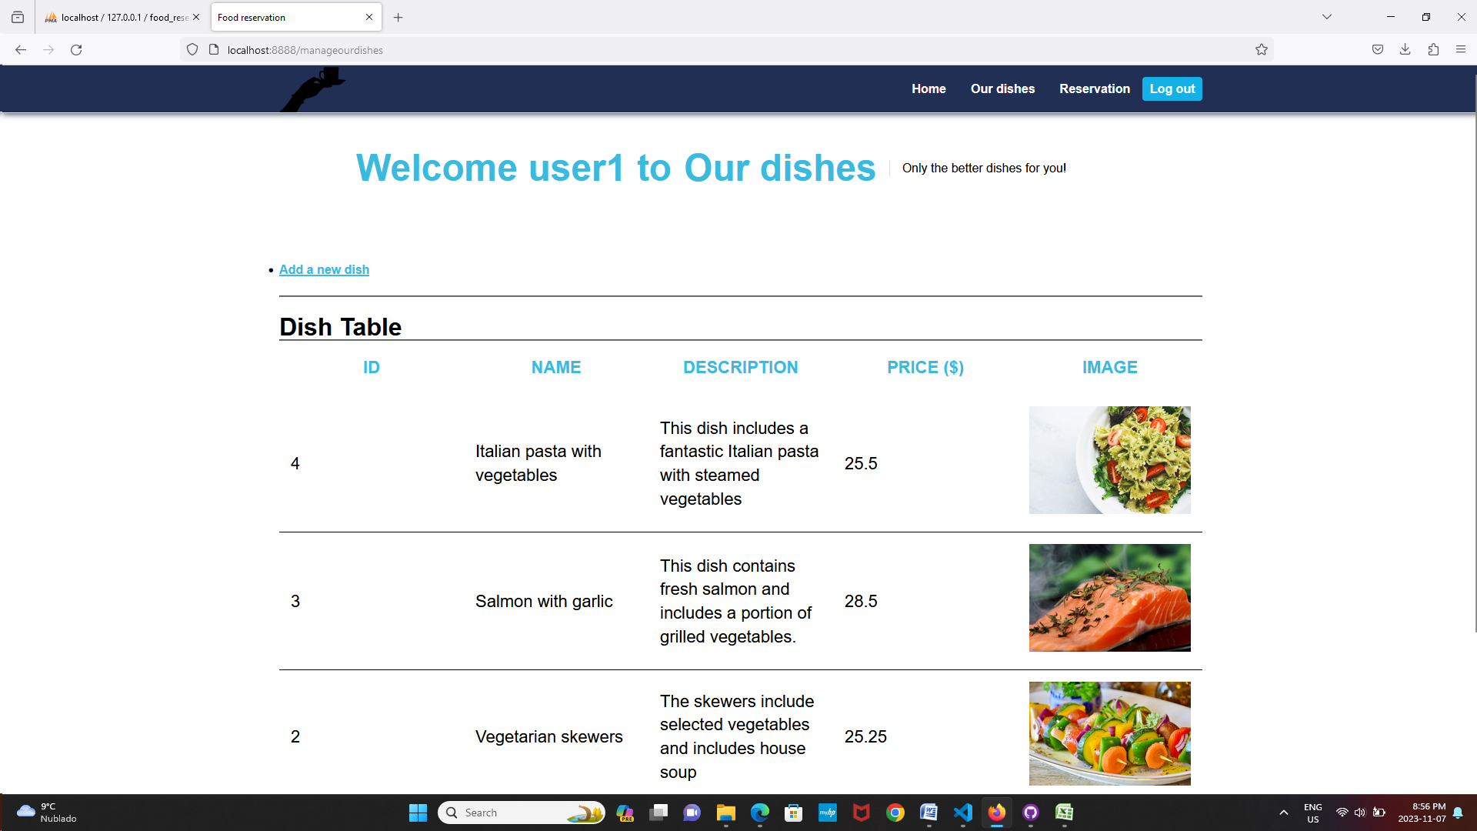
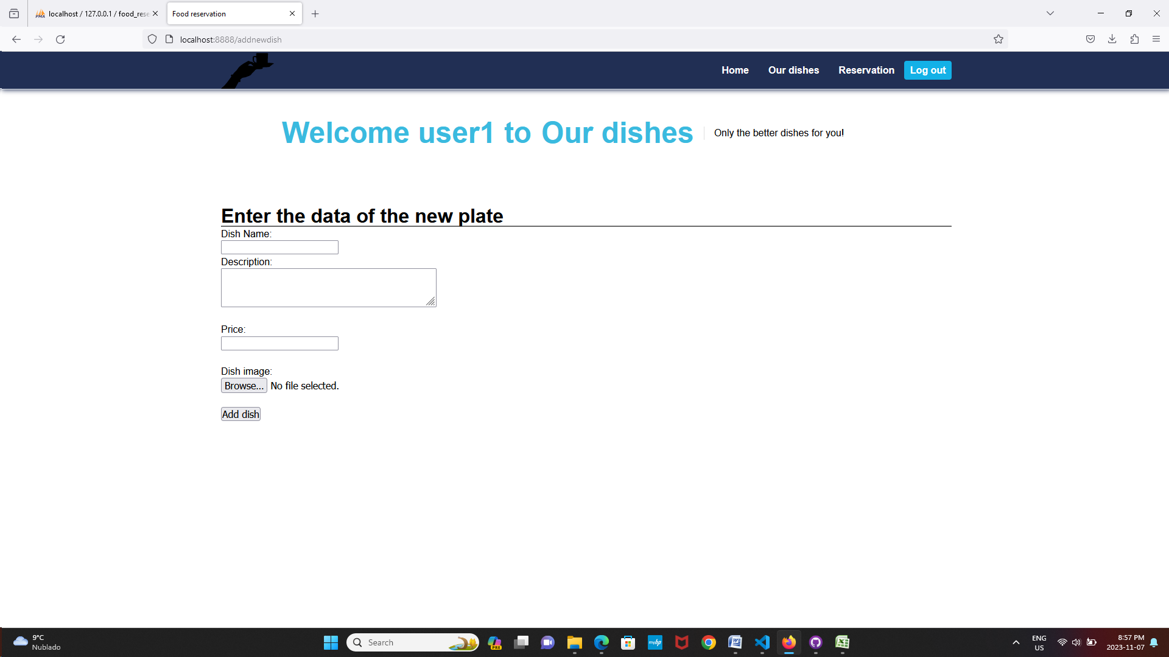
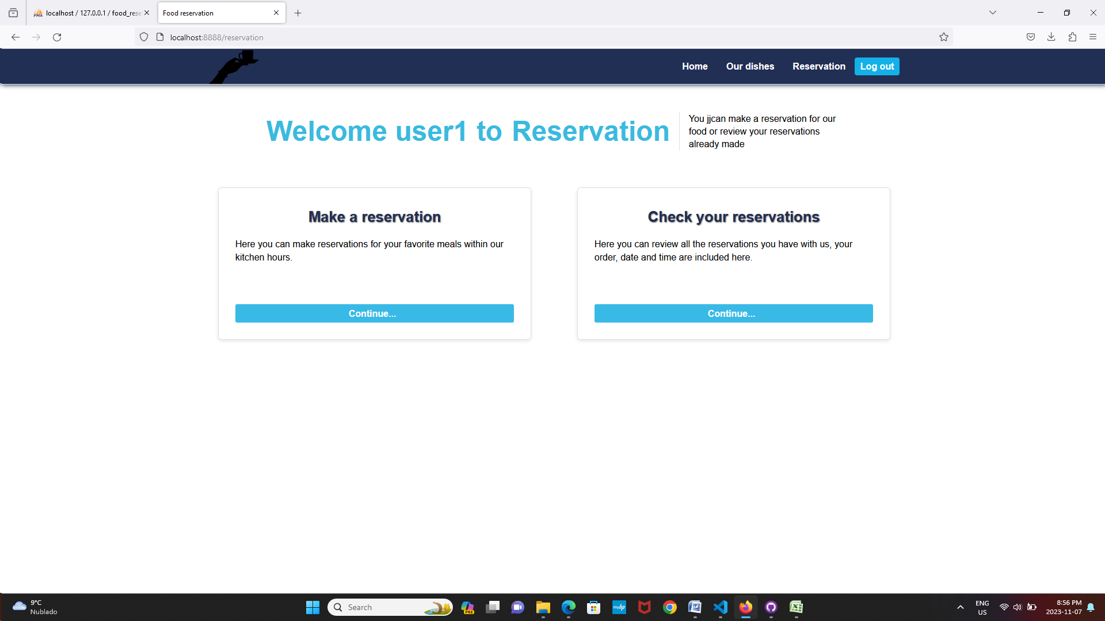
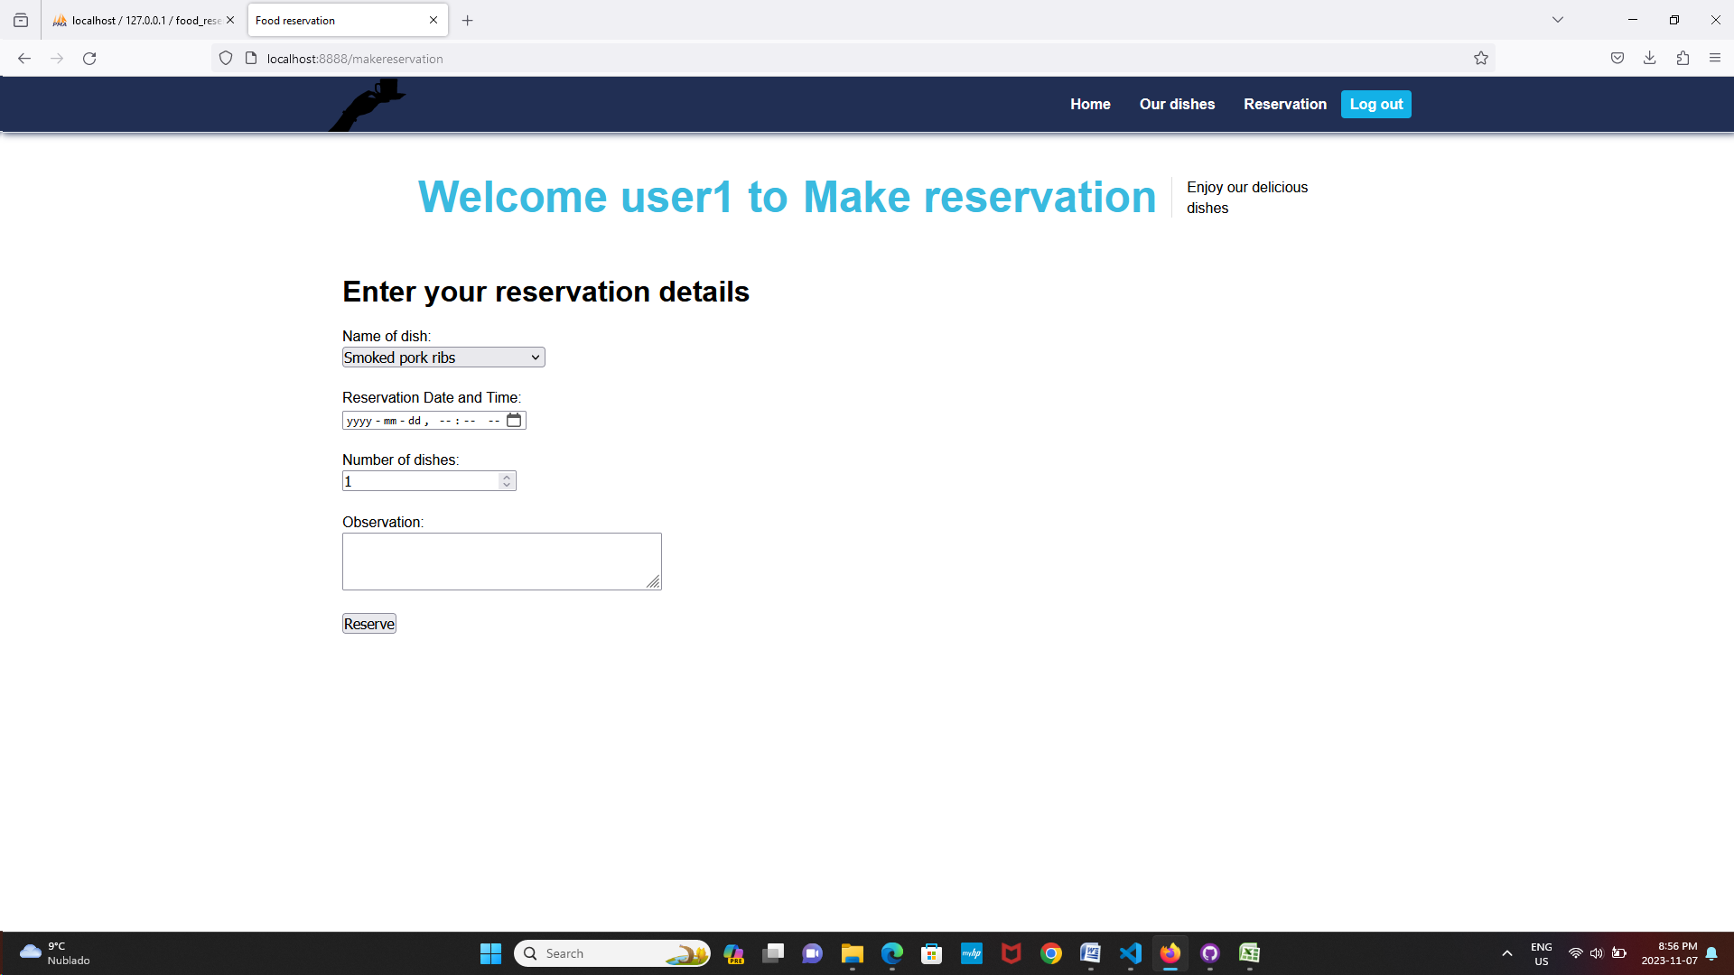
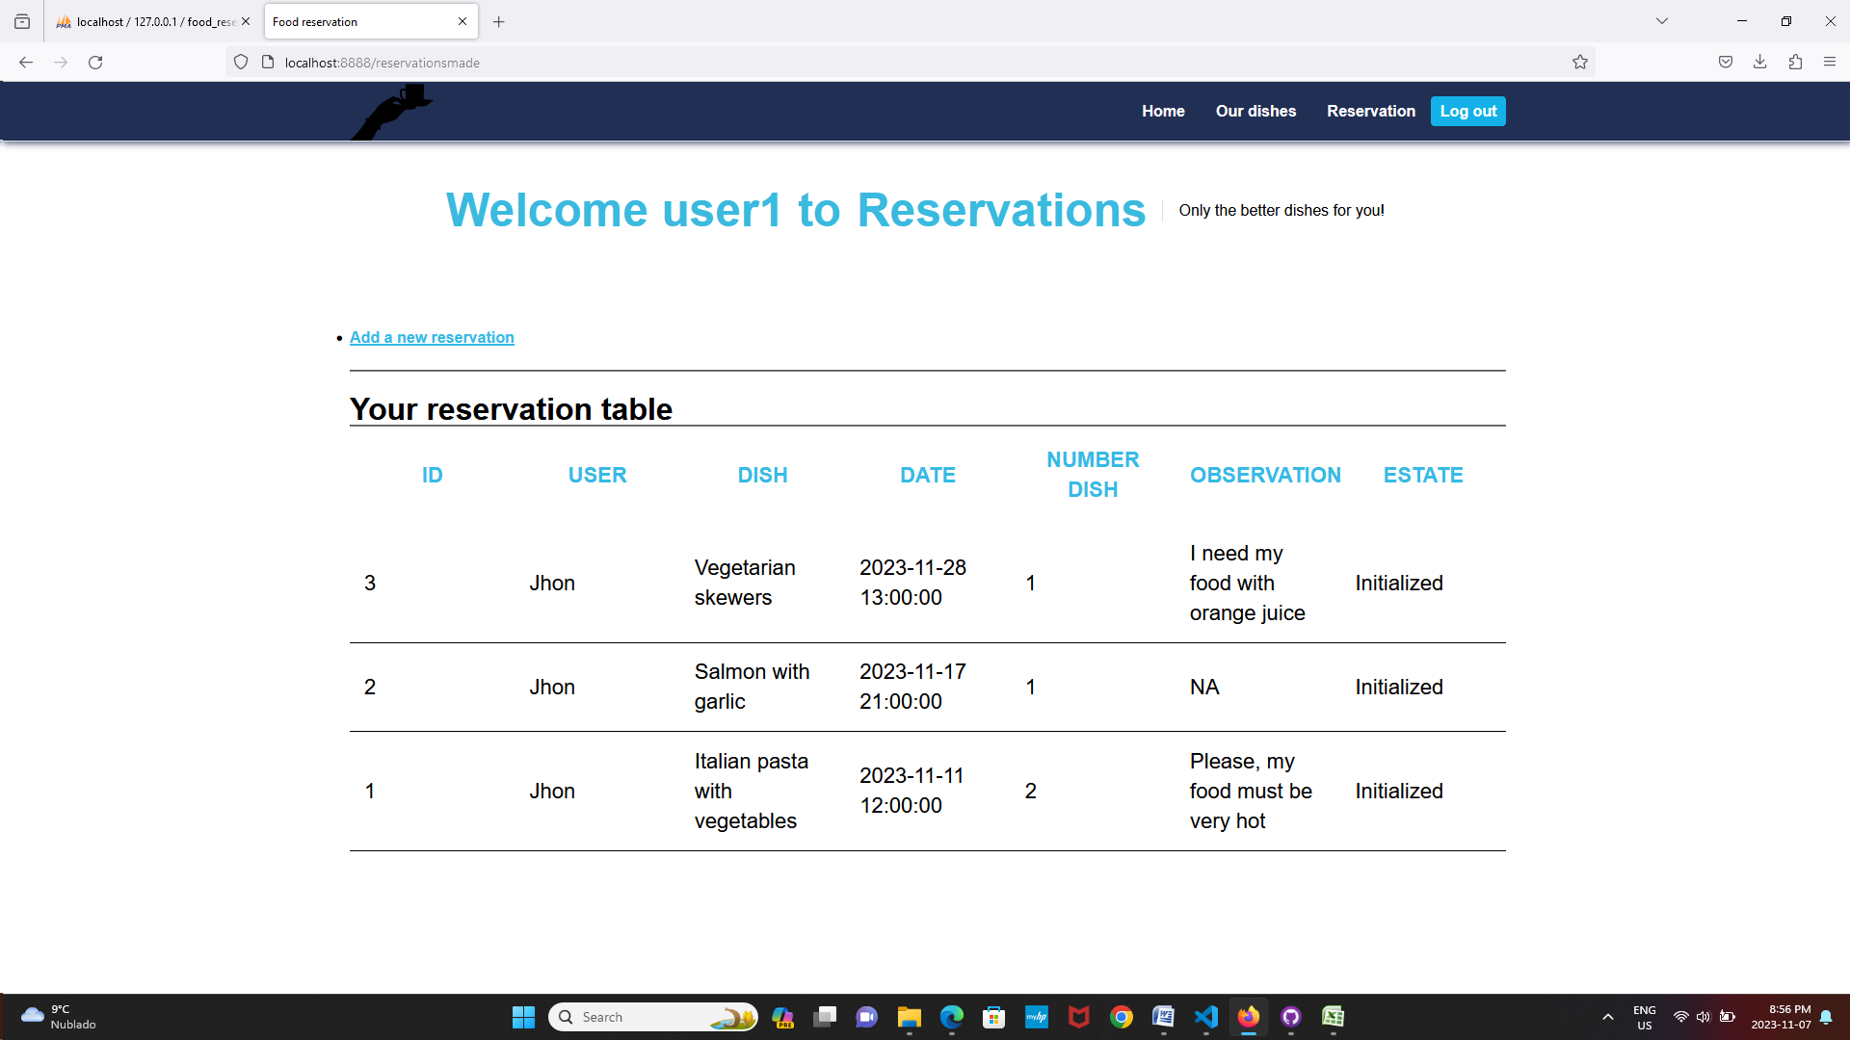

Database Screens
